|  |  |  |
| --- | --- | --- |
| RMSSOFT SOFTWARE HELP DOCUMENTATION | | |
|  |  |  |
|  |  |  |
|  | by Bhekisizwe Mthethwa Pr. Eng |  |
|  |  |  |
|  | | |

|  |  |
| --- | --- |
| Approval Page | |
| Project Name |  |
| Project No | Help Documentation |
| Title | RMSSOFT Software Help Documentation |
| Prepared for | Rolling Stock and Passenger Rail Industry |

|  |  |  |  |
| --- | --- | --- | --- |
| Authored for | Gqunsu Engineering Pty Ltd | Signature | Date |
| By | Bhekisizwe Mthethwa |  |  |
| Designation | System Developer/Director | | |

|  |  |  |  |
| --- | --- | --- | --- |
| Moderated for | Gqunsu Engineering Pty Ltd | Signature | Date |
| By | Tshwaraganang Ramagofu |  |  |
| Designation | Reviewer | | |

|  |  |  |  |
| --- | --- | --- | --- |
| Approved for | N/A | Signature | Date |
| By |  |  |  |
| Designation |  | | |

|  |  |  |  |
| --- | --- | --- | --- |
| Approved for | N/A | Signature | Date |
| By |  |  |  |
| Designation |  | | |

|  |  |  |  |
| --- | --- | --- | --- |
| Distribution List | | | |
| No | Name | Designation | Organisation |
| Master | Programme Office | | |
|  | B. Mthethwa | System Developer/Director | Gqunsu Engineering Pty Ltd |
|  | T. Ramagofu | Reviewer |  |
|  |  |  |  |
|  |  |  |  |
|  |  |  |  |
|  |  |  |  |
|  |  |  |  |
|  |  |  |  |
|  |  |  |  |
|  |  |  |  |

|  |  |  |  |  |
| --- | --- | --- | --- | --- |
| Change History | | | | |
| Rev | Change Control No | Date | Name | Description |
| 00A | Inception | 3 October 2018 | B Mthethwa | Original release. |
|  |  |  |  |  |
|  |  |  |  |  |
|  |  |  |  |  |
|  |  |  |  |  |
|  |  |  |  |  |
|  |  |  |  |  |
|  |  |  |  |  |
|  |  |  |  |  |
|  |  |  |  |  |
|  |  |  |  |  |
|  |  |  |  |  |
|  |  |  |  |  |
|  |  |  |  |  |
|  |  |  |  |  |
|  |  |  |  |  |
|  |  |  |  |  |
|  |  |  |  |  |
|  |  |  |  |  |
|  |  |  |  |  |
|  |  |  |  |  |
|  |  |  |  |  |
|  |  |  |  |  |
|  |  |  |  |  |
|  |  |  |  |  |
|  |  |  |  |  |
|  |  |  |  |  |
|  |  |  |  |  |
|  |  |  |  |  |
|  |  |  |  |  |

Table of Contents

abbreviations 4

1 Introduction 5

1.1 Identification 5

1.2 Document Purpose and Scope 5

2 Referenced Documents 6

3 Help Documentation 7

3.1 General Functions 7

3.1.1 Login Page 7

3.1.2 Terms and Conditions of Use Page 8

3.1.3 Login Password Management Function 8

3.2 Administrator Functions 8

3.2.1 Manage User Access Control Function 8

3.3 User Functions 9

3.3.1 Manage System Settings Function 9

3.3.2 Manage Wheel Measurements Function 9

3.3.3 System Activity Logs Management Function 9

3.3.4 Wheel Measurements Planning Report Management Function 9

3.3.5 Wheel Re-profiling Data Management Function 9

abbreviations

|  |  |
| --- | --- |
| RMSSOFT | Rail Maintenance System Software |
| URL | Uniform Resource Locator |
| CSV | Comma-Separated-Values |

# Introduction

## Identification

The current rail maintenance system software (RMSSOFT) is the first version of its kind and it is identifiable using the uniform resource locator (URL) <https://www.rmssoft.co.za> or <https://rmssoft.co.za>. This software version is version 1.0 and it is shown on the login page of the system together with the RMSSOFT Logo. Do not attempt to enter your details or access the system if the **https** prefix does not exist in the URL. The system under discussion will be identified as RMSSOFT v1.0 henceforth.

## Document Purpose and Scope

The purpose of this document is to exhibit, to the end user, how the RMSSOFT v1.0 system operates. It covers the operational explanations as to how the following system modules operate:

* Login Password Management
* Manage System Settings
* Manage User Access Control
* Manage Wheel Measurements
* System Activity Logs Management
* Wheel Measurements Planning Report Management
* Wheel Re-profiling Data Management

# Referenced Documents

Not Applicable.

# Help Documentation

This section deals with the operational help documentation for the RMSSOFT v1.0 system.

## General Functions

### Login Page

To access the system login page, enter [www.rmssoft.co.za](http://www.rmssoft.co.za) in the address bar of your browser of your choice. Please note that RMSSOFT v1.0 is only compatible with the following browsers:

* Google Chrome version 66 and above
* Mozilla Firefox version 57 and above

You will not be able to login into the system if you are using an unsupported browser. The following Figure 1 shows the message and options you have when faced with an incompatible web browser.

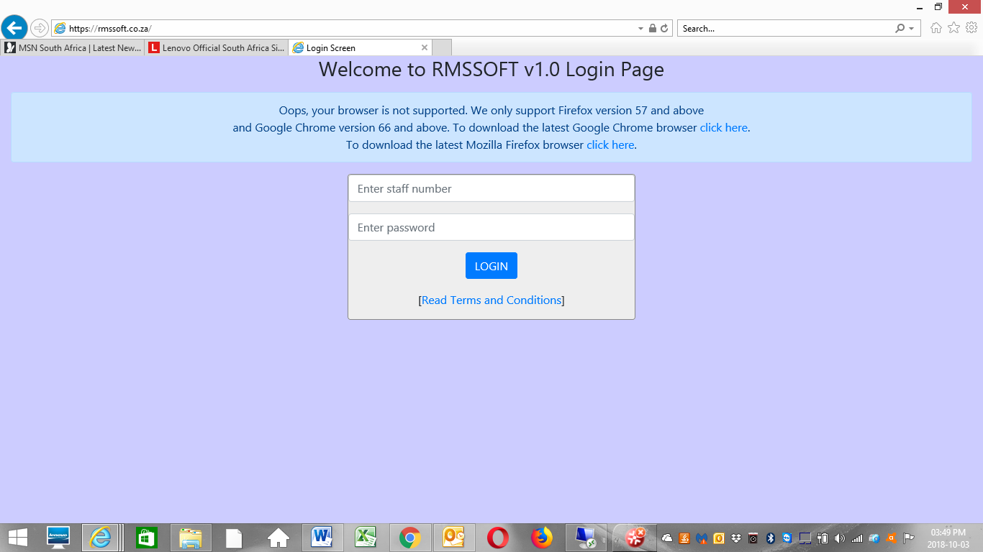

Figure 1, “Login Page showing browser incompatible message”

The user has the option of downloading the latest Google Chrome or Mozilla Firefox web browsers. The message seen above the login form has the direct links to the download pages for both web browsers.

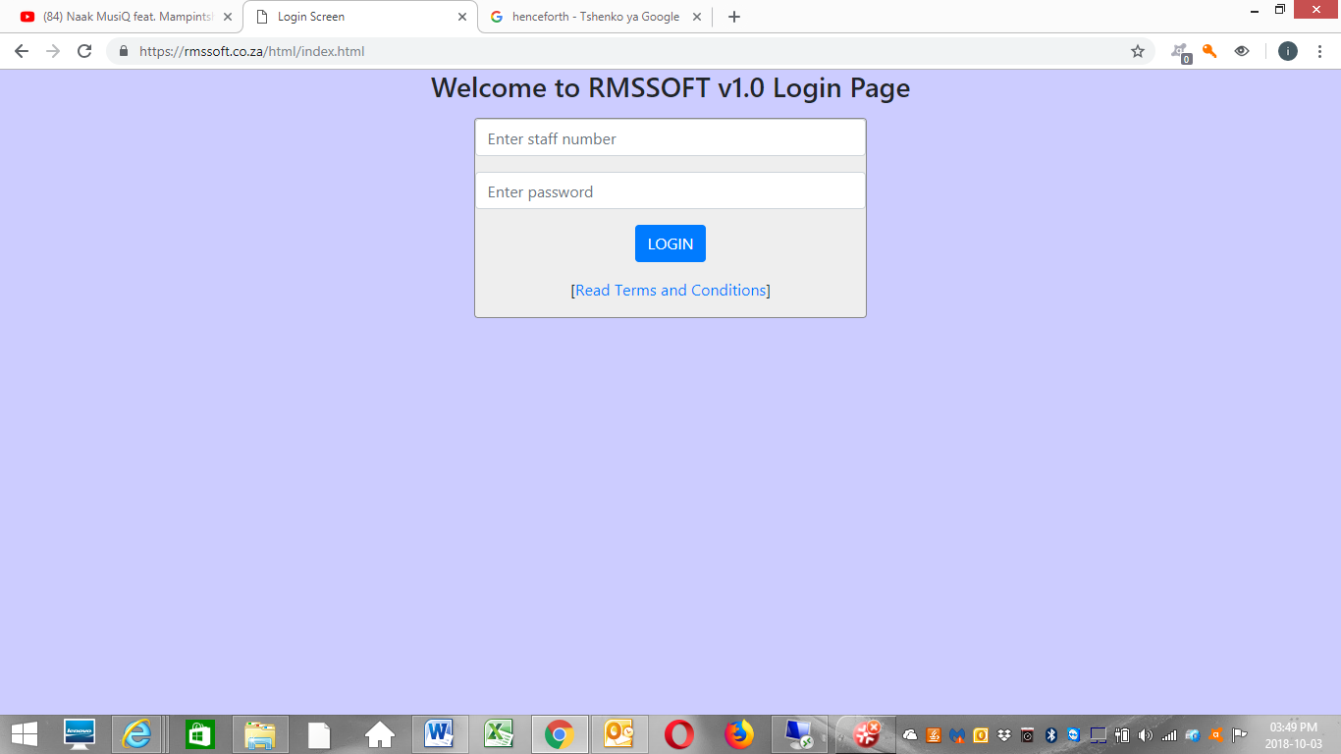

Figure 2, “RMSSOFT v1.0 login page”

Assuming the browser you are using is supported and compatible to RMSSOFT v1.0, Figure 2 shows the login page without the browser incompatibility message. In Figure 2, the login page form requests the completion of the following fields:

* Staff Number (At least 4 or more Alpha-numeric characters)
* Password (At least 8 or more Alpha-numeric characters)

The login page will not log you in if you do not meet the above requirements and you use incorrect login credentials. In order to login into the system, your administrator will create a user account for you and the system will automatically email you the login credentials and link to the RMSSOFT v1.0 system.

### Terms and Conditions of Use Page

To view the terms and conditions of use of the RMSSOFT v1.0 system, click on the “Read Terms and Conditions” hyper-link below the LOGIN button shown in Figure 2.

### Login Password Management Function

This section deals with the user password management for logging into the system. Figure 3 shows the fields that need to be completed. It also shows the profile details of the currently logged in user. This is where the user updates their login password by specifying the following fields:

* Current Password (At least 8 or more Alpha-numeric characters)
* New Password (At least 8 or more Alpha-numeric characters)
* Repeat New Password (At least 8 or more Alpha-numeric characters and must match new password)

After the above requirements have been met, you can update the password and an email will be sent to you with the new password.

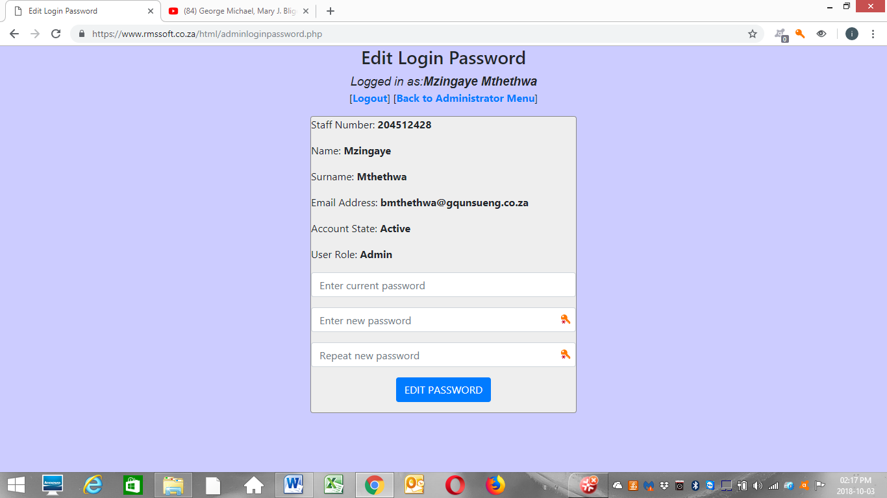

Figure 3, “Edit Login Password Screen”

## Administrator Functions

This function is only visible to the system administrators who are assigned by the Super Administrator (RMSSOFT v1.0 System Developers) and/or the end user System Administrator. The non-administrator user roles do not have access to this functionality and therefore their menu will not show this module.

### Manage User Access Control Function

This section deals with the management of user accounts, resetting of user passwords and management of user roles.

#### Reset User Password Function

To access the reset user password function, the administrator must click the “Manage User Access Control>>Reset User Password” links.

If a specific staff member has forgotten their system login password, the administrator can reset the staff member’s login password by entering the staff member’s staff number into the Password Recovery Form and clicking the RESET PASSWORD button as shown in Figure 4. The system will automatically generate a random new password and email the staff member the new password. If the staff number entered does not match a specific user account, the system will notify the administrator via a pop-up dialogue box.

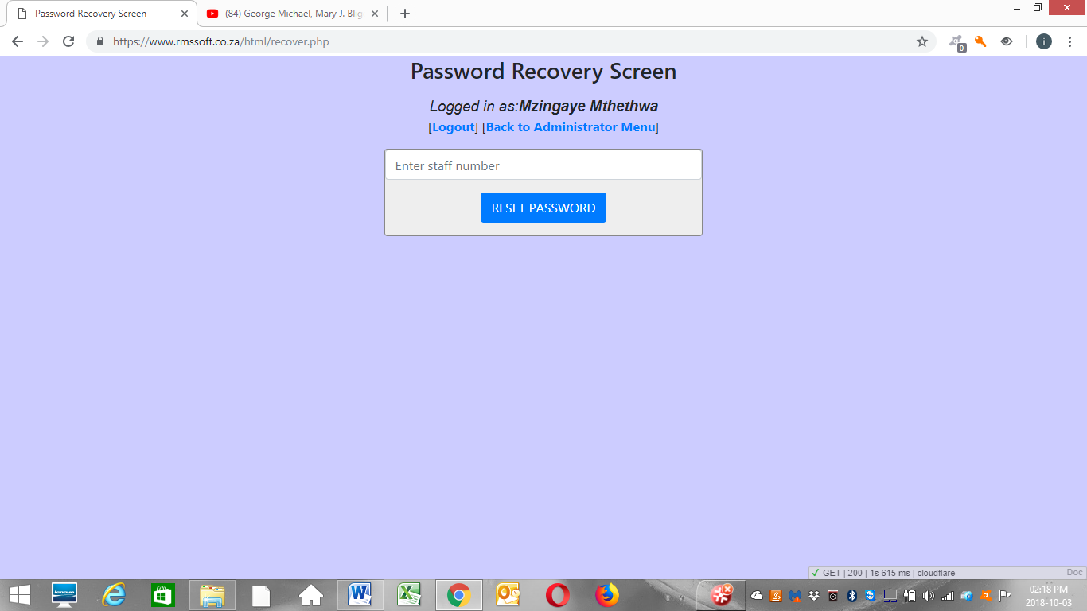

Figure 4, “Password Recovery Screen”

#### User Accounts Management Function

1. Create User Account

When the system administrator wants to add a user account into the system, they access the “create user account” page by clicking the links “Manage User Access Control>>User Accounts Management>>Create User Account”. Figure 5 shows the page that appears.

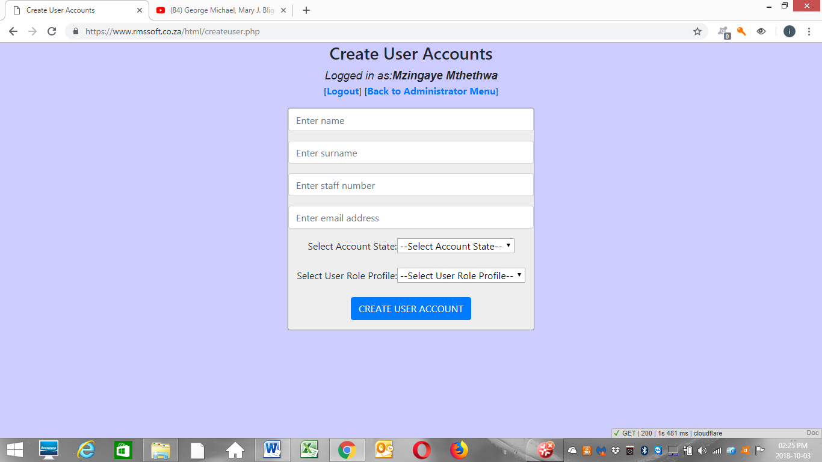

Figure 5, “Create User Accounts Screen”

The administrator then completes the following fields as shown in Figure 5:

* Name (At least Two or more characters, hyphens, space and letters only)
* Surname (At least Two or more characters, hyphens, space and letters only)
* Staff Number (At least 4 or more Alpha-numeric characters only, must be unique in system)
* Email Address (Valid Email address)
* Account State (Select Active or In-Active)
* User Role Profile (Select User Role Profile)

The user role profile defines the occupation of the staff member whose account is being created. The user role profiles need to be created first before assigning user accounts to the user role profiles. The staff number entered must be unique in the system, since duplicate staff numbers are not allowed. Please make sure that you enter the staff number correctly as it is not editable at a later stage.

After the successful creation of the user account, an email is automatically sent to the staff member notifying them that their account has been created and their system login credentials are stated in the same email. The password is randomly generated and the staff members are encouraged to update it to a password that can be easily remembered.

1. Edit User Account

When the system administrator wants to update a user account in the system, they access the “edit user account” page by clicking the links “Manage User Access Control>>User Accounts Management>>Edit User Account”. Figure 6 shows the page that appears.

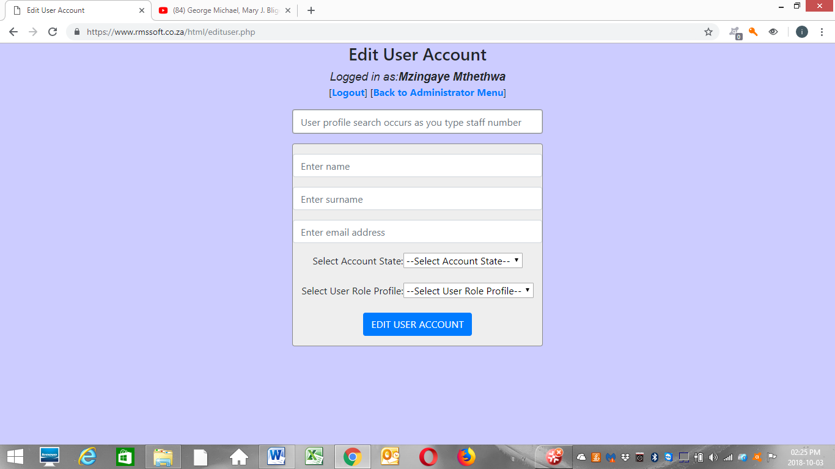

Figure 6, “Edit User Account Screen”

The administrator can then edit the following fields as shown in Figure 6:

* Name (At least Two or more characters, hyphens, space and letters only)
* Surname (At least Two or more characters, hyphens, space and letters only)
* Email Address (Valid Email address)
* Account State (Select Active or In-Active)
* User Role Profile (Select User Role Profile)

In order to pull up the details of the user account, the administrator enters the staff number, of the user account in question, in the search form above the “Edit User Account Form”. Make sure that the user account profile that appears is indeed the correct profile. After updating the details successfully, an email is sent to the account holder stating that their profile has been updated.

#### User Roles Management Function

1. Create User Role

When the system administrator wants to add a user role into the system, they access the “create user role” page by clicking the links “Manage User Access Control>>User Accounts Management>>Create User Role”. Figure 7 shows the page that appears.

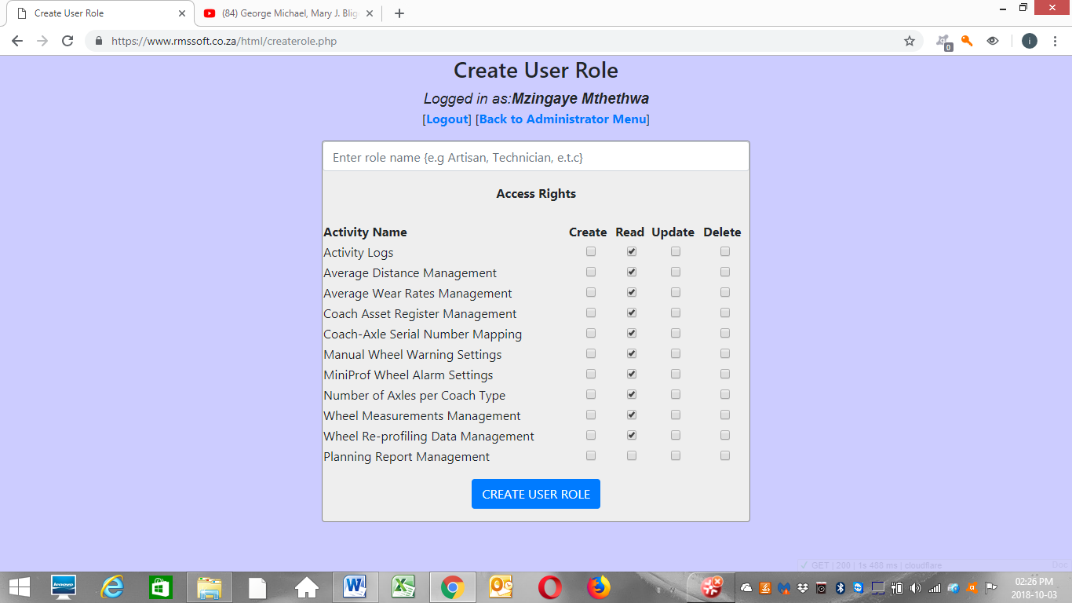

Figure 7, “Create User Role Screen”

The screen shows a field requesting the user role name that needs to be added. The system does not allow duplicate user role names. The page also shows the default access rights that will be assigned to the user role. The administrator is free to set the appropriate access rights for the user role they are creating.

Clicking on the Planning Report Management activity name “Read” access right checkbox automatically shows the planning report column names. This is where the administrator can specify what columns will be visible in the planning report for a specific user role. This information hiding is important if you do not want to share sensitive information with specific stakeholders or user roles. The default settings are that no columns are visible.

1. Edit User Role Access Rights

When the system administrator wants to edit a user role access rights in the system, they access the “edit user role access rights” page by clicking the links “Manage User Access Control>>User Accounts Management>>Edit User Role Access Rights”. Figure 8 shows the page that appears.

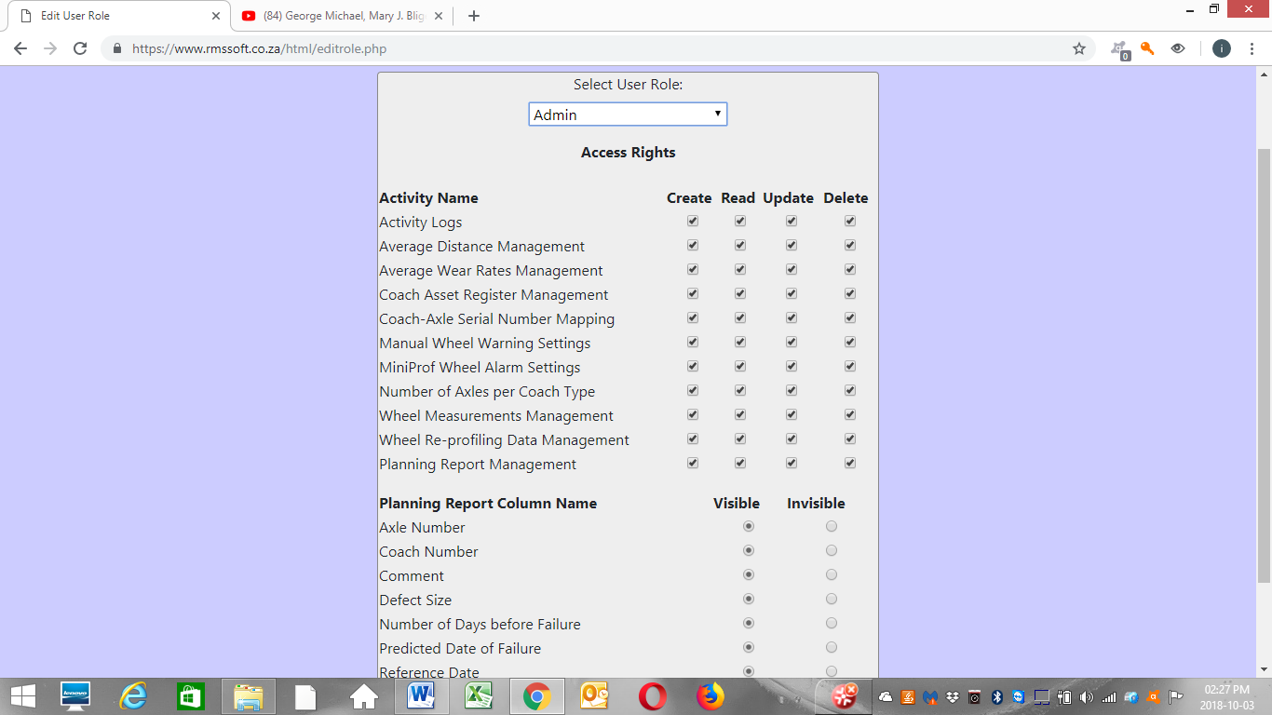

Figure 8, “Edit User Role Access Rights”.

The administrator is free to update the Create, Read, Update or Delete access rights for each system activity per user role. The administrator can select the user role in question from the dropdown menu. This will in turn pull up the access rights for that specific user and the administrator can change these previously assigned access rights. If a specific RMSSOFT v1.0 user falls under a specific user role that does not have access rights to perform the Create, Read, Update or Delete functions under a specific activity, and the user attempts to view or create or update under that activity, the system will prevent the actions from completion and they will be notified via a dialogue box that they do not have access rights to perform the actions.

## User Functions

The functions in this section are common to both administrator users and non-administrator users.

### Manage System Settings Function

This section deals with the setup of the system settings for proper functionality of the system. It is compulsory for the system settings to be set in order for the system to work. Please make sure you setup this system before attempting to import wheel measurements or generate planning reports.

#### Asset Register Management Function

1. Add Asset to System

When the user wants to add an asset to the asset register in the system, they access the “Add Asset to System” page by clicking the links “Manage System Settings>>Asset Register Management>>Add Asset to System”. Figure 9 shows the page that appears.

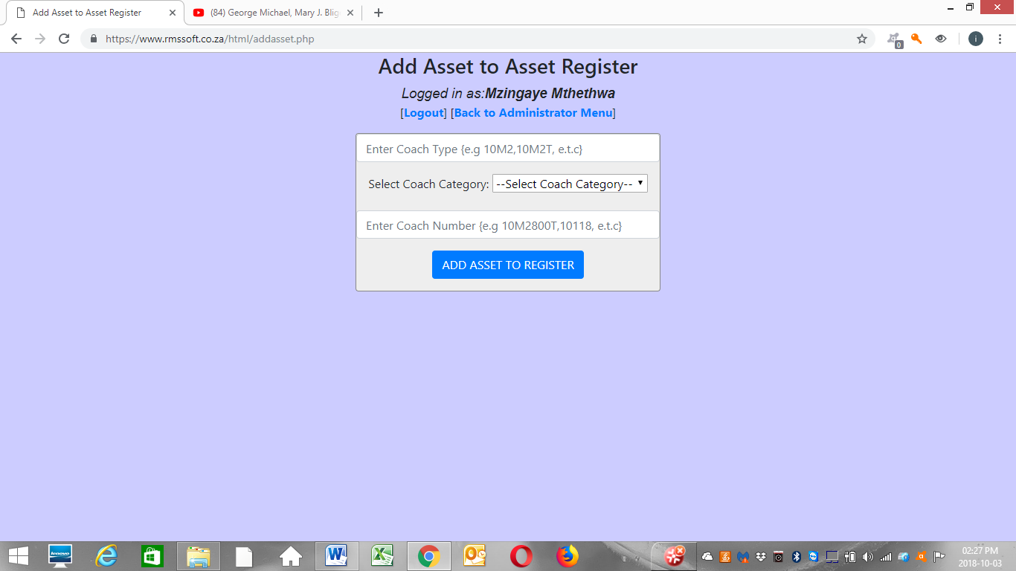

Figure 9, “Add Asset to Asset Register Screen”

The user must complete the following fields

* Coach Type (Two or more characters, i.e Only digits, letters, hyphens and spaces allowed)
* Coach Category (Select between a Locomotive, Motor Coach or Trailer Coach)
* Coach Number (Two or more characters, i.e Only digits, letters, hyphens and spaces allowed, must be unique in the system)

The coach number must be unique in the system otherwise the system will prevent the addition of such an asset into the system.

1. Edit Asset in System

When the user wants to update an asset in the asset register in the system, they access the “Edit Asset in System” page by clicking the links “Manage System Settings>>Asset Register Management>>Edit Asset in System”. Figure 10 shows the page that appears.

As shown in Figure 10, the user must enter the coach number in the search form above the “Edit Asset Form”. The search form enables the user to pull up the asset record for that specific coach number. The search form searches for the asset record as you enter the coach number. The user is then free to edit the Coach Type and Coach Number for that asset.

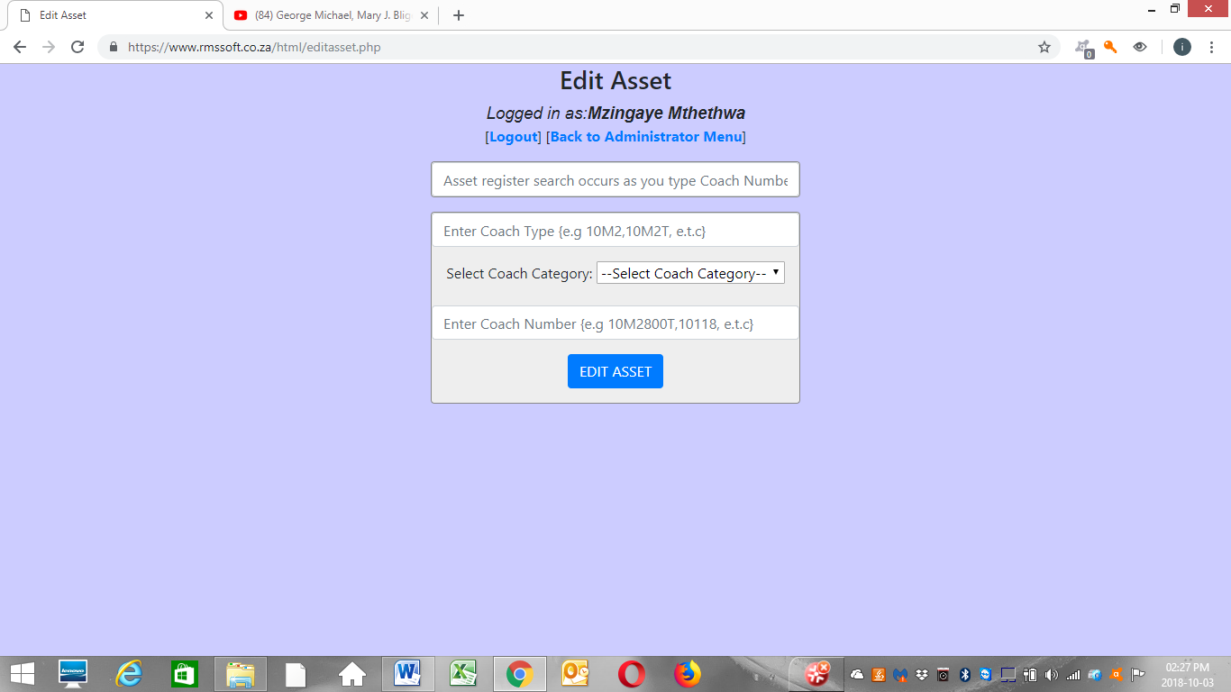

Figure 10, “Edit Asset Screen”

1. Import Asset Register

When the user wants to import an asset register in the system, they access the “Import Asset Register” page by clicking the links “Manage System Settings>>Asset Register Management>>Import Asset Register”. Figure 11 shows the page that appears.

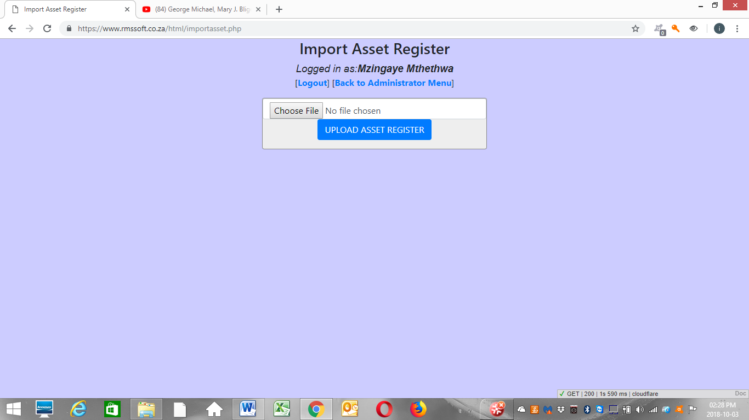

Figure 11, “Import Asset Register Screen”

This page gives the user the ability to add multiple assets simultaneously which is much faster if you have a lot of assets to add. All the user needs to do is create a Microsoft Excel file with the assets added in the format shown in Figure 12.

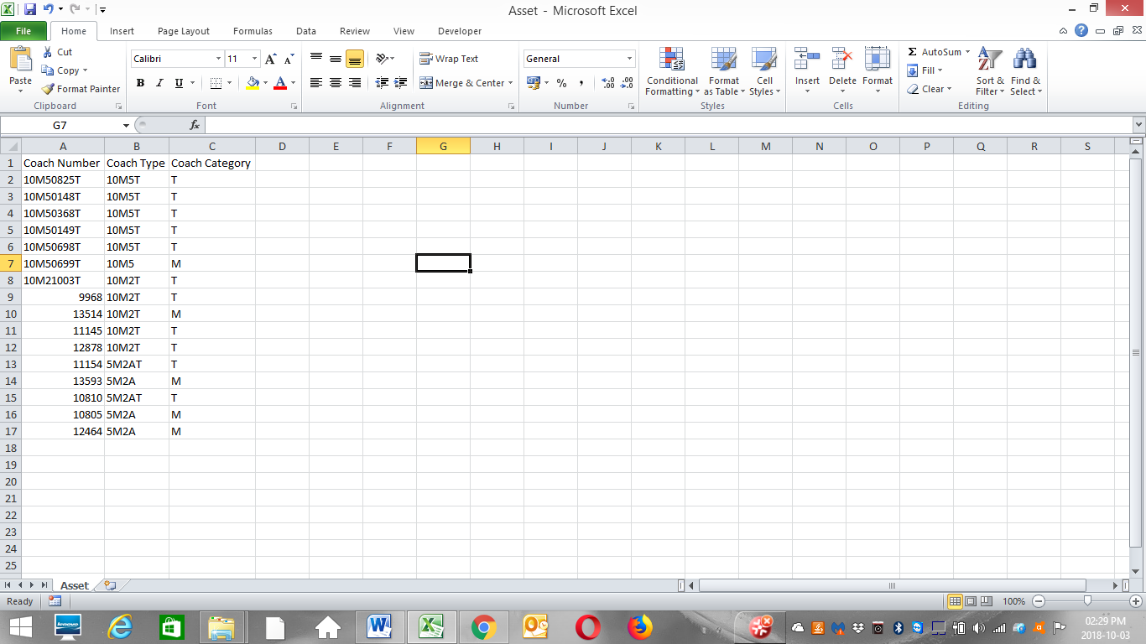

Figure 12, “CSV File with listed Assets”

The column names must match the names shown in Figure 12 including the case as the column names are **case sensitive**. Make sure the order of the column names is as shown in Figure 12 and that no column name is missing in the MS Excel file. Export a comma-separated-values (CSV) file from MS Excel and this exported CSV file is the file format that is supported by the RMSSOFT v1.0 system. Import this CSV file using the form shown in Figure 11. Make sure that the **Coach Category values are in the set {L, M, T}.** No other values are supported. Please adhere to these requirements.

#### Axle Serial Number-Coach Mapping Management Function

1. Add Axle Serial Number-Coach Mapping

When the user wants to add the axle serial number to coach mapping in the system, they access the “Add Axle Serial Number-Coach Mapping” page by clicking the links “Manage System Settings>>Axle Serial Number-Coach Mapping Management>>Add Axle Serial Number-Coach Mapping”. Figure 13 shows the page that appears.

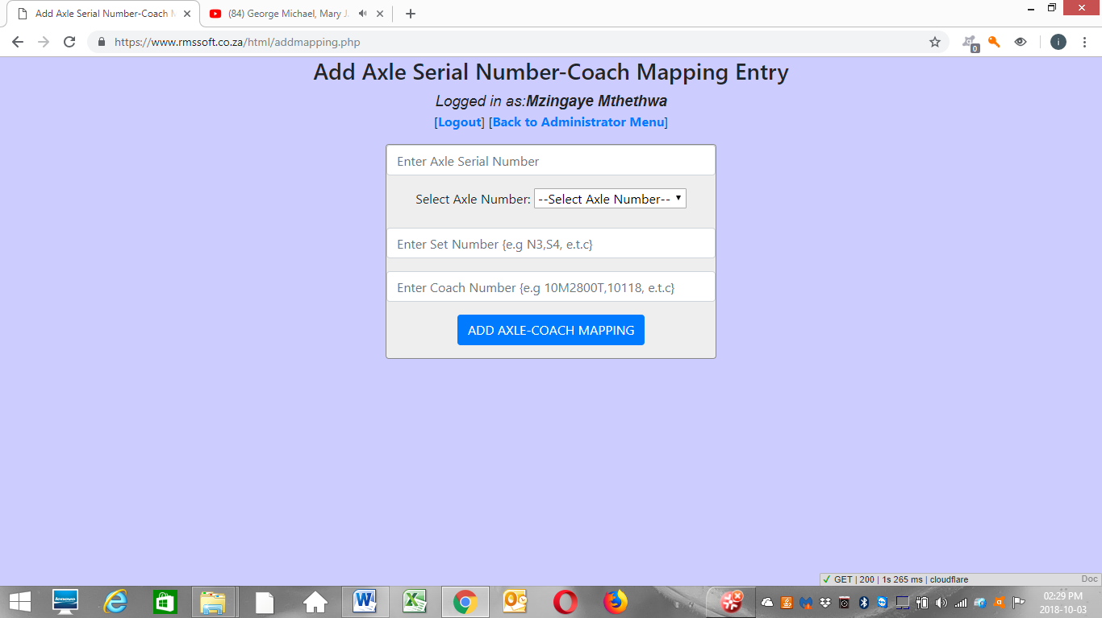

Figure 13, “Add Axle serial Number-Coach Mapping Entry Screen”

The user must complete the following fields

* Axle Serial Number (Two or more characters, i.e Only digits, letters, hyphens and spaces allowed)
* Axle Number (Select between 1, 2 , 3 and 4)
* Set Number (Two or more characters, i.e Only digits, letters, hyphens and spaces allowed)
* Coach Number (Two or more characters, i.e Only digits, letters, hyphens and spaces allowed)

1. Import Axle Serial Number-Coach Mapping

When the user wants to import an Axle Serial Number-Coach Mapping in the system, they access the “Import Axle Serial Number-Coach Mapping” page by clicking the links “Manage System Settings>> Axle Serial Number-Coach Mapping Management>> Import Axle Serial Number-Coach Mapping”. Figure 14 shows the page that appears.

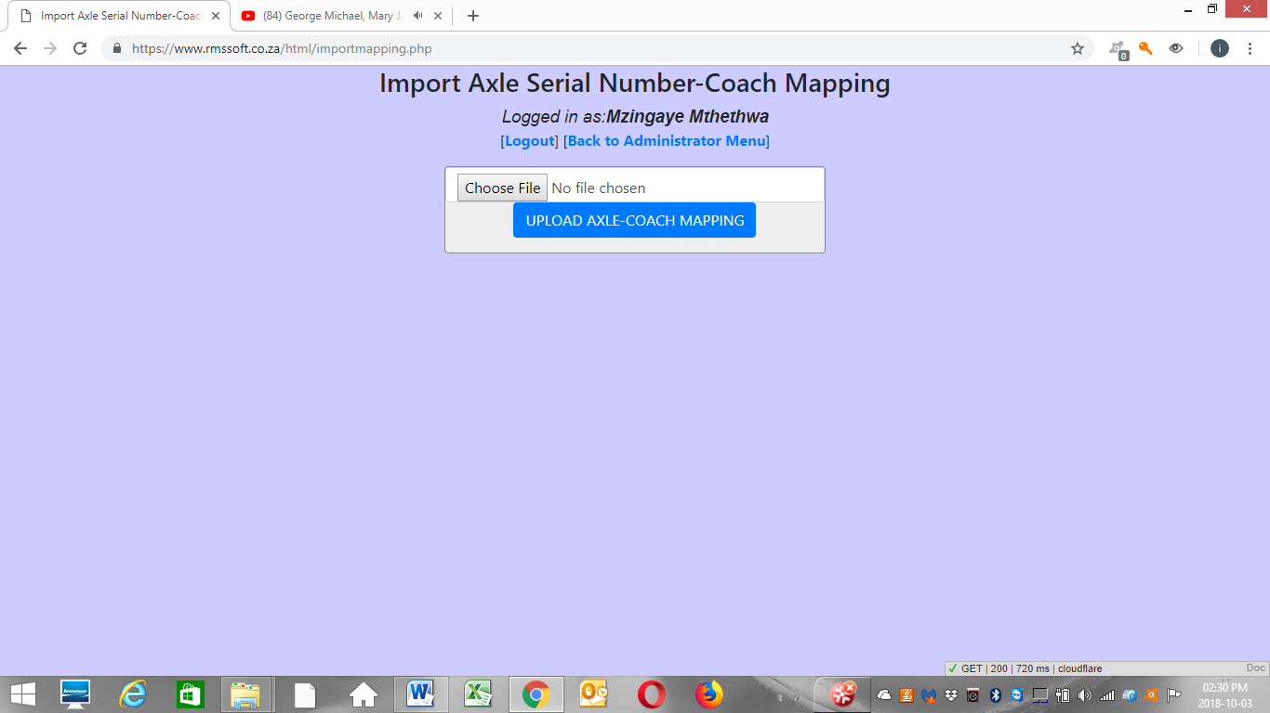

Figure 14, “Import Axle Serial Number-Coach Mapping Screen”

This page gives the user the ability to add multiple axle serial numbers to coach mappings simultaneously which is much faster if you have a lot of mappings to add. All the user needs to do is create a Microsoft Excel file with the mappings added in the format shown in Figure 15.

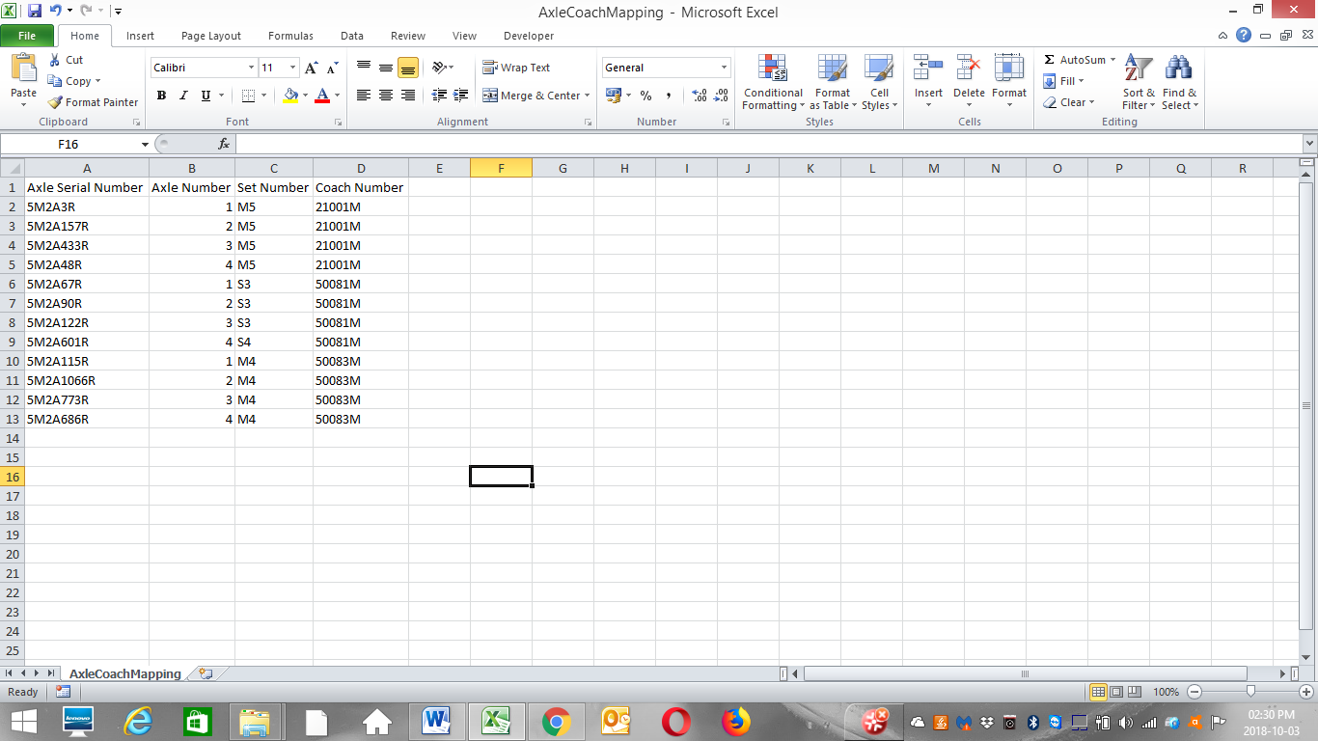

Figure 15, “CSV File with listed Mappings”

The column names must match the names shown in Figure 15 including the case as the column names are **case sensitive**. Make sure the order of the column names is as shown in Figure 15 and that no column name is missing in the MS Excel file. Export a comma-separated-values (CSV) file from MS Excel and this exported CSV file is the file format that is supported by the RMSSOFT v1.0 system. Import this CSV file using the form shown in Figure 14. Make sure that the Axle Number is between the values of **1 and 4 inclusive.**

1. View Axle Serial Number-Coach Mapping

When the user wants to view the Axle Serial Number-Coach Mapping in the system, they access the “View Axle Serial Number-Coach Mapping” page by clicking the links “Manage System Settings>> Axle Serial Number-Coach Mapping Management>>View Axle Serial Number-Coach Mapping”. Figure 16 shows the page that appears.

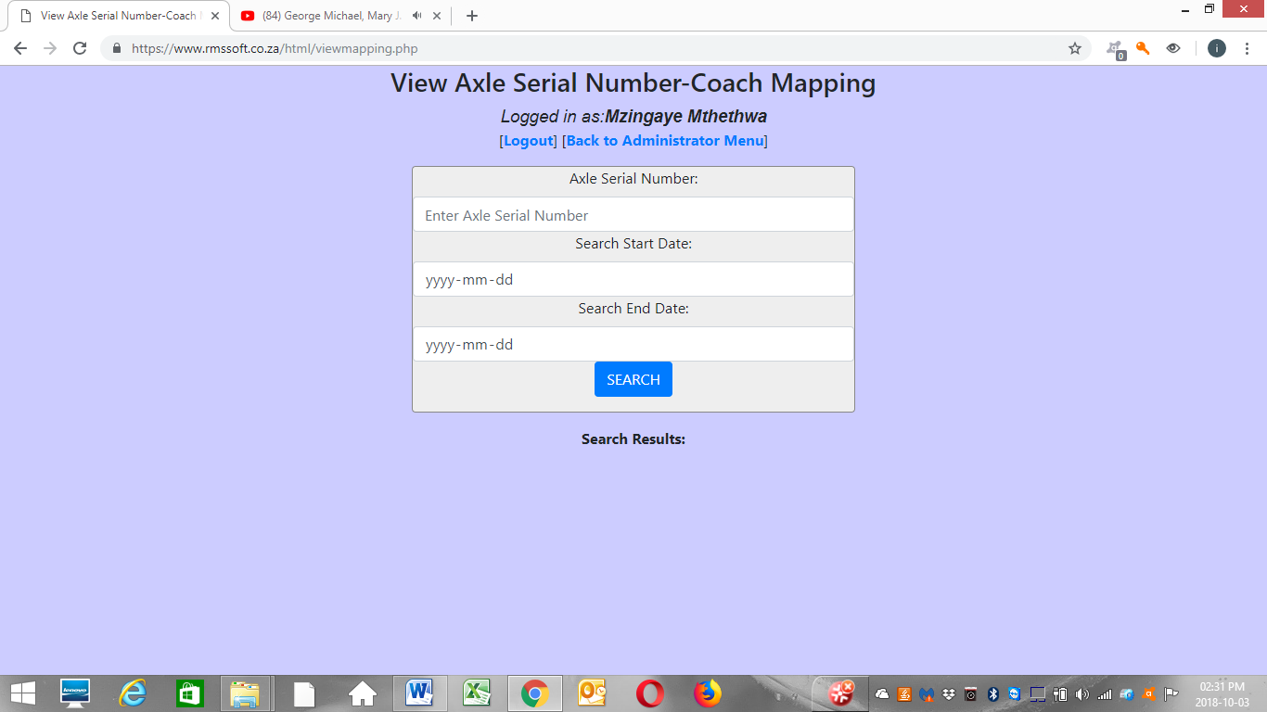

Figure 16, “View Axle Serial Number-Coach Mapping Screen”

The form in Figure 16 requires that the user enters the Axle Serial Number of interest and the Search Start and End Dates for the creation of the Axle Serial Number to Coach Mapping. The system returns the search results just below the above form shown in Figure 16.

#### Daily Distance Travelled Setting Management Function

#### Manual Wheel Measurements Alarm Settings Management Function

#### MiniProf Wheel Measurements Alarm Settings Management Function

#### Number of Axles Per Coach Management Function

#### Wheel Wear Rate Settings Management Function

### Manage Wheel Measurements Function

#### Manual Wheel Measurements Management Function

#### MiniProf Wheel Measurements Management Function

1. Import MiniProf Wheel Measurements
2. View Wheel Measurements

#### Wheel Measurements Alarm Event Management Function

### System Activity Logs Management Function

### Wheel Measurements Planning Report Management Function

### Wheel Re-profiling Data Management Function

#### Add Wheel Re-profiling Data Function

#### Edit Wheel Re-profiling Data Function